Before you advance any further in the lesson, here’s the truth tables for logical AND ( && ) and logical OR ( || ).

**&& (AND)**

| **A** | **B** | **A && B** |
| --- | --- | --- |
| true | true | true |
| true | false | false |
| false | true | false |
| false | false | false |

**|| (OR)**

| **A** | **B** | **A || B** |
| --- | --- | --- |
| true | true | true |
| true | false | true |
| false | true | true |
| false | false | false |

**Truth tables** are used to represent the result of all the possible combinations of inputs in a logical expression. A represents the boolean value on the left-side of the expression and B represents the boolean value on the right-side of the expression.

Truth tables can be helpful for visualizing the different outcomes from a logical expression. However, do you notice anything peculiar about the truth tables for logical AND and OR?

**Short-circuiting**

[[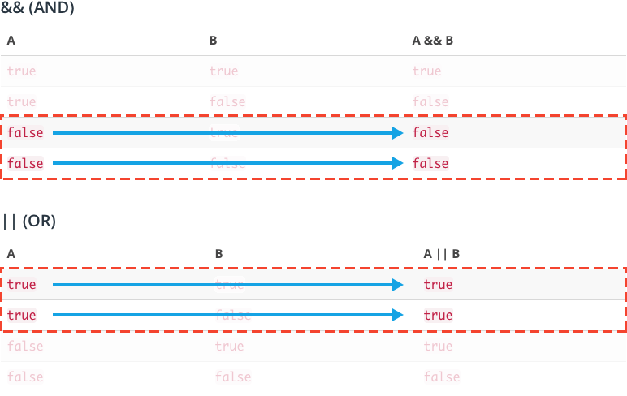](https://classroom.udacity.com/courses/ud803/lessons/3ace947b-b5f6-40c1-bc11-3ec98fd1d936/concepts/39d374f9-d917-4038-94de-bf63323c51f0)](https://classroom.udacity.com/courses/ud803/lessons/3ace947b-b5f6-40c1-bc11-3ec98fd1d936/concepts/39d374f9-d917-4038-94de-bf63323c51f0)

[In some scenarios, the value of B in logical AND and OR doesn't matter.](https://classroom.udacity.com/courses/ud803/lessons/3ace947b-b5f6-40c1-bc11-3ec98fd1d936/concepts/39d374f9-d917-4038-94de-bf63323c51f0)

In both tables, there are specific scenarios where regardless of the value of B, the value of A is enough to satisfy the condition.

For example, if you look at A AND B, if A is *false*, then regardless of the value B, the total expression will always evaluate to false because both A *and* B must be true in order for the entire expression to be true.

This behavior is called **short-circuiting** because it describes the event when later arguments in a logical expression are not considered because the first argument already satisfies the condition.